赞美大世大佬！！！

以下代码添加在 function updateState() {******}之后， // Reset required storage and prioritized resources之前

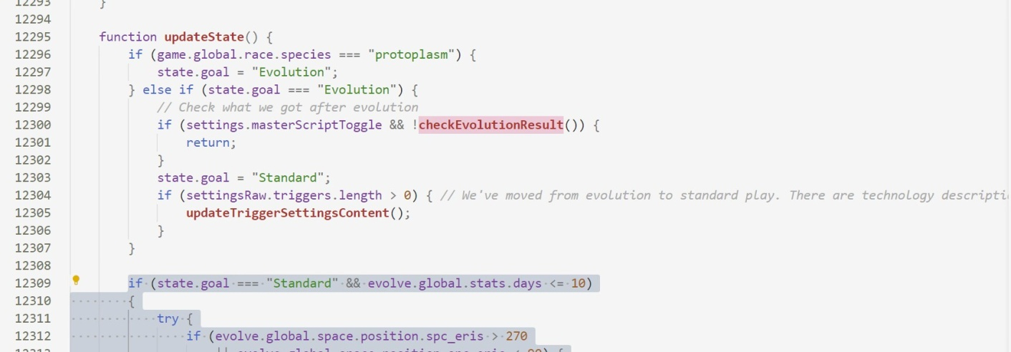

if (state.goal === "Standard" && evolve.global.stats.days <= 10)

{

try {

if (evolve.global.space.position.spc_eris > 270

|| evolve.global.space.position.spc_eris < 90) {

GameLog.logDanger("special", `糟糕，阋神星太远了，位置：`+evolve.global.space.position.spc_eris, ['progress']);

let resetButton = document.querySelector(".reset .button:not(.right)");

if (resetButton.innerText === game.loc("reset_soft")) {

if (settings.evolutionQueueEnabled && settingsRaw.evolutionQueue.length > 0) {

if (!settings.evolutionQueueRepeat) {

addEvolutionSetting();

}

settingsRaw.evolutionQueue.unshift(settingsRaw.evolutionQueue.pop());

}

updateSettingsFromState();

state.goal = "GameOverMan";

resetButton.disabled = false;

resetButton.click();

}

}

} catch (error) {

}

}

if (state.goal === "Standard" && evolve.global.stats.days <= 10)

{

try {

if (evolve.global.race.hooved> 0) {

GameLog.logDanger("special", `糟糕，我们遇到马蹄了`, ['progress']);

let resetButton = document.querySelector(".reset .button:not(.right)");

if (resetButton.innerText === game.loc("reset_soft")) {

if (settings.evolutionQueueEnabled && settingsRaw.evolutionQueue.length > 0) {

if (!settings.evolutionQueueRepeat) {

addEvolutionSetting();

}

settingsRaw.evolutionQueue.unshift(settingsRaw.evolutionQueue.pop());

}

updateSettingsFromState();

state.goal = "GameOverMan";

resetButton.disabled = false;

resetButton.click();

}

}

} catch (error) {

}

}